

2018 UBC OPEN

**March 30th – 31st**, **2018**

UBC Rashpal Dhillon Track and Field Oval (Wesbrook/16th Ave.)

**Meet Director:** Reid Graham (778) 828-3484 [ubcmeetdirector@gmail.com](mailto:ubcmeetdirector@gmail.com)

**Events:** 100m, 200m, 400m, 800m, 1500m, 10 000m, 3k/5k RW, 100mH (W), 110mH (M), 400mH, 4x100, LJ, HJ, TJ, PV, SP, JAV, DT, HT, Heptathlon (W), Decathlon (M)

*- RWs and 10,000m will be M/W combined. HT, DT, TJ will be M/W combined.*

**Entries:** Entry fees are $US12 per event. We do offer a team fee option: US$300.00/gender. All entries and payments are done online at Direct Athletics: <https://www.directathletics.com/meets/track/53404.html>

**Entry deadline:** CLOSED

Late entries are up to the discretion of the meet organizers. Late entry fee is $25 per event.

All athletes entering this meet must have a current BC Athletics membership, or equivalent, from another province or country.

**Check-in Procedures:**

All TRACK athletes are to check in at least **30min** prior to the start of their event at the check in table.

All FIELD athletes are to check in at their event **30min** prior to the start of their event.

**Schedule, Results, and Meet Information:**

For the most up-to-date versions of the Schedule, Entries, Results, and Meet Information please follow the appropriate link in the site as seen below: <https://github.com/UBCTrackMeet/UBCOpenSchedules>

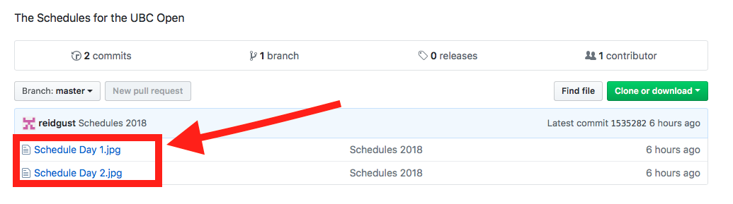 **Technical Notes:**

*Throwing Implements* – Please note that personal throwing implements must be weighed at least 60min before event starts. Weigh-in will be done in the equipment room, north of the track.

* Age group athletes may employ the implements required for their age, but must provide their own implements and have them weighed in.

*Track Events* – Timed finals. Hurdle heights will be set at “open” heights only (exceptions will be made for age-group multi-event athletes).

*Field Events* – For throws and horizontal jumps, every athlete will get 3 attempts with the top eight athletes receiving 3 additional attempts.

**Parking at the UBC Track:**

1. Busses: If you want to reserve parking for busses please coordinate with the meet director as soon as possible; otherwise, busses can be parked on East Mall, 16th Ave, and Wesbrook Mall.
2. There is free parking on 16th Ave on the way into Campus from Blanca St. (good option for buses) but it’s an 800m walk to the track.
3. There is metered parking on the south side of Wesbrook Mall between 16th Ave and Thunderbird Blvd.
4. There is pay parking in the Thunderbird Parkade on Thunderbird Blvd. just off of Wesbrook Mall.
5. We will be paying officials’ parking so officials please keep your receipts and get reimbursement from the registration desk.

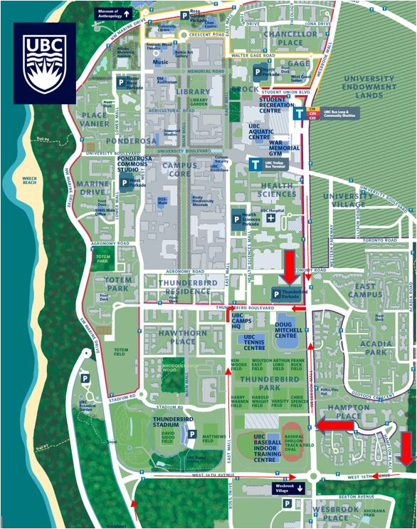

**Directions from the US:**

1. Take I5 North to the US/Can Border Crossing (Peace Arch)
2. Go through Canadian Customs.
3. Continue NW on Highway 99 to the Oak St. Bridge.
4. Continue North on Oak St to 49th Ave.
5. Turn left on to 49th Ave and head west to SW Marine Dr.
6. Turn right on to SW Marine Dr.
7. Continue on SW Marine Dr.
8. Stay on this until 16th Ave and then turn right onto 16th Ave.
9. At the 2nd round-about go left on Wesbrook Mall.
10. The track is immediately on the left.
11. For the parkade continue on Wesbrook Mall to Thunderbird Boulevard, turn left and then right into Thunderbird Parkade.

